**ASSIGNMENT**

Create two S3 buckets in different region upload a file in one S3 bucket and transfer the same file from one S3 bucket to other S3 bucket.

First we have to create s3 bucket in one region and create another bucket in another region and name as source and destination buckers.

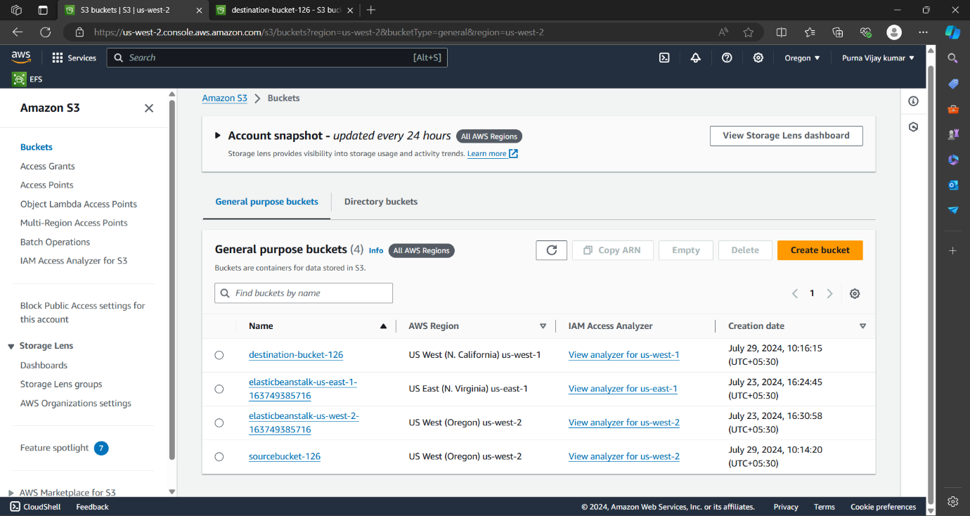

And enable bucket versioning in both source and destination buckets.

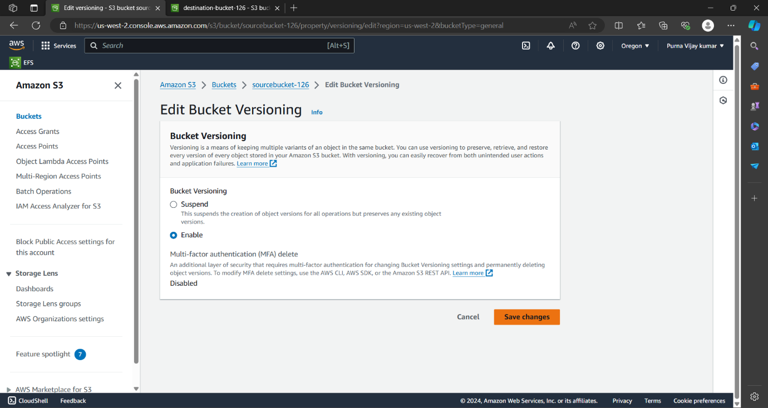

Create a cross region replication rule in source bucket.

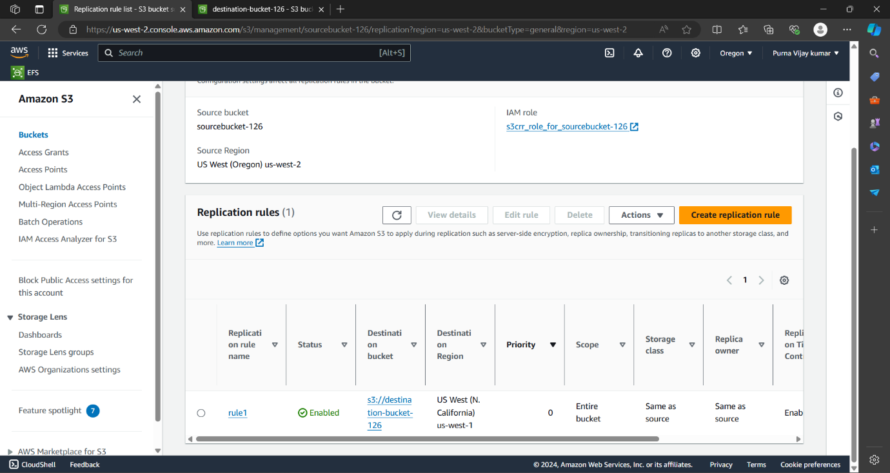

Upload a file or floder in the source bucket.

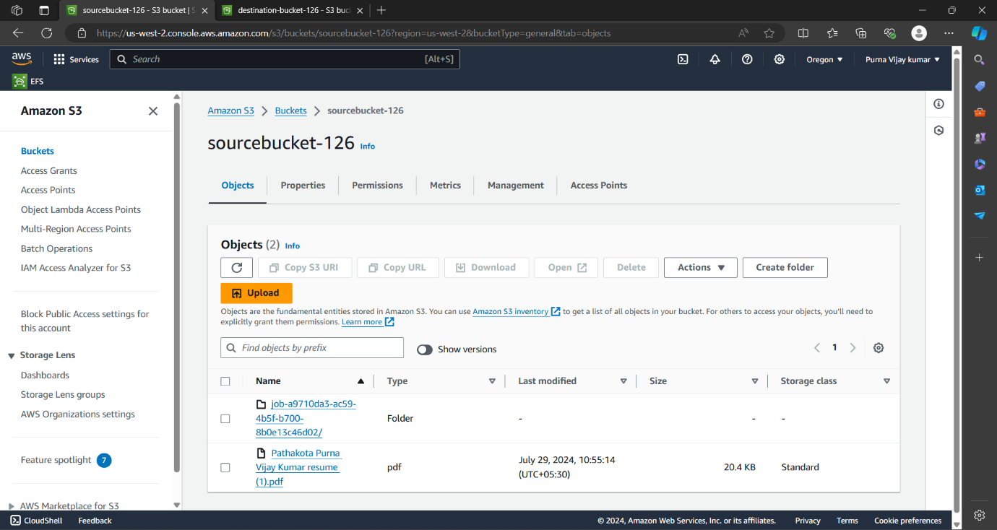

And it replicated in the destination bucket. we can see in the below figure.

